**Virtual Reality (VR)**

**Name:** Gotam Sai Varshith

**Reg. No:** 22BCE1605

**Course Name:** Human Computer Interaction

**Course Code:** BCSE415L

**Slot:** C1 + TC1

**🔍 Topic: Literature Survey on Virtual Reality (VR)**

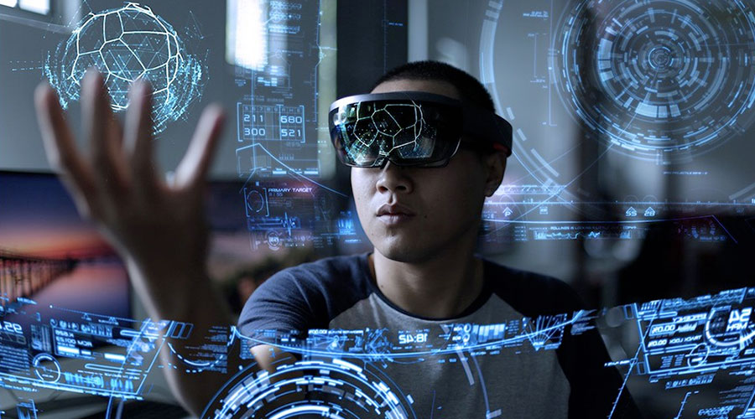

**📄 1. Immersion Metrics for Virtual Reality**

**Authors**: Matias N. Selzer & Silvia M. Castro  
**Source**: arXiv (2022)

* **Algorithms Used**:  
  Multivariate regression modelling to compute immersion scores based on system hardware and software variables.
* **Methodology**:  
  Experimental approach collecting data from diverse VR setups; regression analysis to find immersion predictors.
* **Performance Metrics**:  
  Regression model accuracy (R²), variable contribution weights, and validation error.

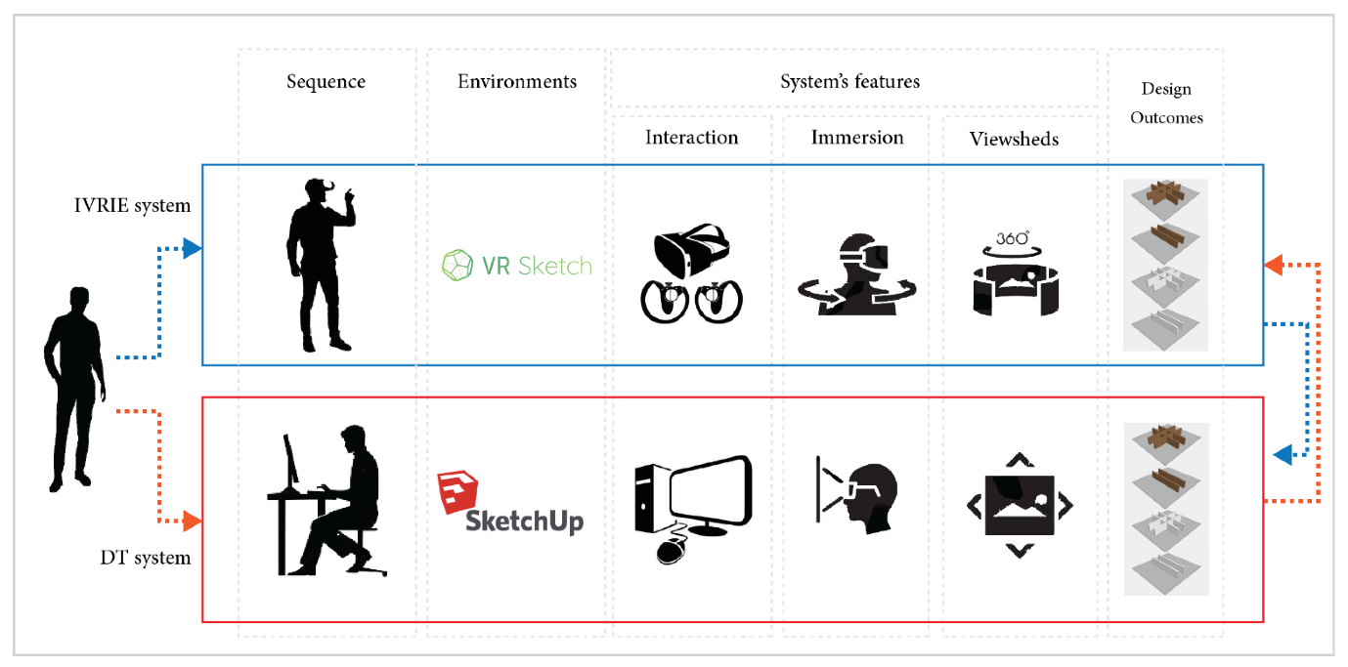

**Abstract (10 lines)**:

* This paper proposes a set of immersion metrics grounded in both hardware (e.g., display resolution, FOV, tracking quality) and software (e.g., rendering frame rate, interactivity latency).
* The authors conducted controlled experiments across diverse VR configurations. Statistical regression identified relationships between system variables and immersion scores.
* Key predictors were high FOV, low latency, and natural input fidelity.
* The immersion model achieved high explanatory power (R² > 0.8).
* The methodology supports generalization to new VR setups.
* These metrics facilitate comparison across systems and help designers optimize immersion. From an HCI perspective, the work enables evaluation of interface changes on immersion.
* It aligns with proposed project goals of optimizing HCI design for enhanced user experience.

**📄 2. Evaluation of Virtual Reality Interaction Techniques: The Case of 3D Graph**

**Authors**: Nicola Capece et al.  
**Source**: arXiv (2023)

* **Algorithms Used**:  
  Gesture recognition, 6-DOF controller processing.
* **Methodology**:  
  Within-subject user study comparing hand gestures vs. controllers in HMD and spherical display setups.
* **Performance Metrics**:  
  Immersion level, ease of use, usefulness, behavioral intention (via Likert scale).

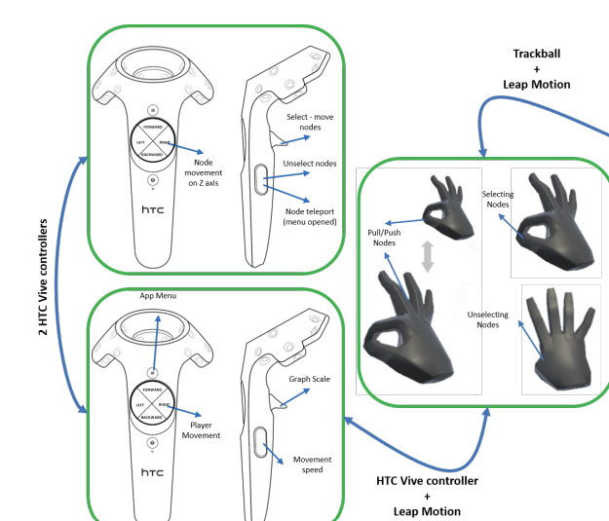

**Abstract (10 lines)**:

* This study compares VR interaction modes—traditional controllers vs. hand-tracking gestures—across two display environments (HMD and spherical displays) using a 3D graph exploration task.
* Twenty users performed navigation and object manipulation tasks using each technique. Subjective measures were collected through questionnaires assessing immersion, ease, usefulness, and intention to use.
* The experiment revealed that hand-tracking offered higher realism and perceived naturalness, especially in spherical setups.
* Ease-of-use favoured controllers, although not significantly.
* Users indicated stronger behavioural intention with gestures.
* The findings highlight trade-offs between efficiency and immersive Ness.
* This comparison clarifies how interaction mode shapes HCI experience.
* The results inform design decisions in immersive VR interface development.

**📄 3. A Comparative Study of Interaction Time and Usability of Using Controllers and Hand Tracking in VR Training**

**Authors**: Chaowanan Khundam et al.  
**Source**: MDPI Informatics (2020)

* **Algorithms Used**:  
  Hand-tracking gesture recognition vs. controller input mapping.
* **Methodology**:  
  Quasi-experimental study involving 48 medical trainees using VR controllers and hand tracking for intubation training.
* **Performance Metrics**:  
  Task time, System Usability Scale (SUS), USEQ (usefulness, ease of use, learning, satisfaction).

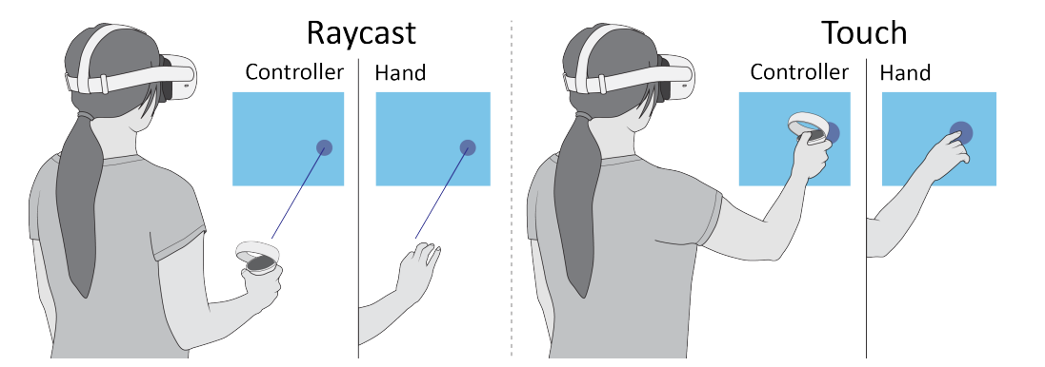

**Abstract (10 lines)**:

* Focusing on VR medical training, participants completed tasks using either handheld controllers or bare-hand gestures.
* Objective interaction times were logged for each task procedure.
* Subjective questionnaires—SUS and USEQ—captured usability, satisfaction, and intuitive use.
* Statistical tests showed no significant difference in task completion time or usability scores between input modes.
* Many users preferred controllers for reliability, but hand-tracking scored higher on perceived realism.
* Interviews revealed gestures made the experience more authentic but sometimes suffered from tracking errors.
* Authors recommend hand input for skill-based training, pending hardware refinement.
* This informs HCI research around balancing realism and performance in VR training interfaces.

**📄 4. Measuring Cognitive Conflict in VR with Feedback-Related Negativity (FRN)**

**Authors**: Avinash Kumar Singh et al.  
**Source**: arXiv / HCI Conference (2017)

* **Algorithms Used**:  
  EEG signal processing; Feedback-Related Negativity (FRN) extraction.
* **Methodology**:  
  Two-phase study with EEG sensors and tracked-hand object selection, using variable selection radii to trigger conflict.
* **Performance Metrics**:  
  FRN amplitude, error rate, user response time, subjective user comfort.

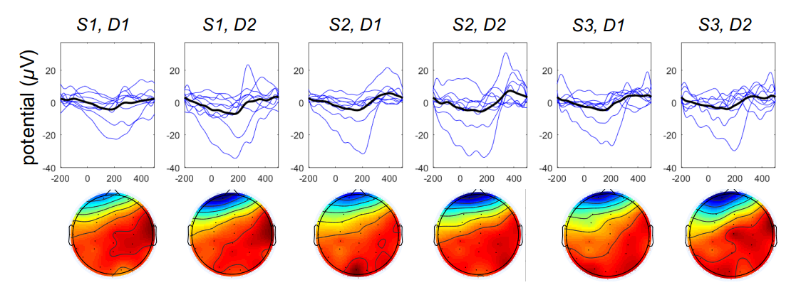

**Abstract (10 lines)**:

* This paper introduces an EEG‑based framework to quantify cognitive conflict during VR tasks by measuring feedback‑related negativity.
* Participants performed 3D object selection using hand tracking in VR; the selection radius was varied to induce mis-selections.
* Behavioural data (error rates, reaction times) were collected alongside EEG recordings.
* The analysis showed that FRN amplitude increased with selection difficulty and errors, confirming sensitivity to cognitive conflict.
* Virtual hand realism also modulated FRN responses, linking to the uncanny valley.
* The framework supports designers in evaluating interface-induced cognitive load.
* From an HCI standpoint, it highlights the value of neurophysiological metrics in assessing immersive interaction techniques.

**📄 5. A Survey on the Design of Virtual Reality Interaction Interfaces**

**Authors**: Meng-Xi Chen et al.  
**Source**: MDPI Sensors (2024)

* **Algorithms Used**:  
  Not applicable (systematic literature review using qualitative analysis).
* **Methodology**:  
  Review of 438 papers from 2011–2023, categorized into interaction types and evaluation methods.
* **Performance Metrics**:  
  Task completion time, usability scores, error rates, subjective experience scores.

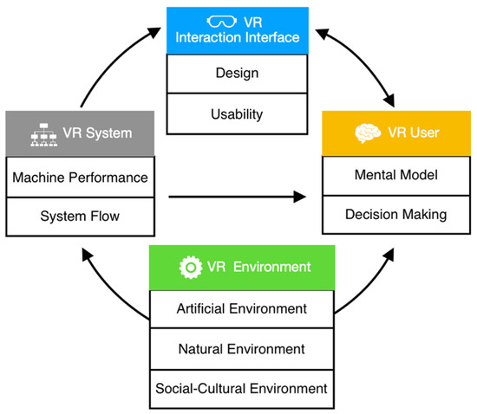

**Abstract (10 lines)**:

* This comprehensive review examines interaction interface design in VR from 2011 to 2023.
* It categorizes interaction tasks such as navigation, pathfinding, and system control, and analyses empirical studies across these domains.
* Objective and subjective performance measures—including task time, errors, SUS, user satisfaction, and immersion—are synthesized.
* The survey highlights that menu-based UI, overview maps, and tactile gestures improve usability for navigation and control tasks.
* Major gaps include lack of multi-sensory interface research and limited participant diversity. The review identifies the absence of unified evaluation standards.
* It provides design guidelines and future research directions.
* The findings anchor your project’s literature foundation and help justify chosen methodology.

**📚 References**

* Selzer, M. N., & Castro, S. M. (2022). *Immersion Metrics for Virtual Reality*. arXiv:2206.07748.
* Capece, N., et al. (2023). *Evaluation of VR Interaction Techniques: The Case of 3D Graph*. arXiv:2302.05660.
* Khundam, C., et al. (2020). *A Comparative Study of Interaction Time and Usability...*. Informatics, 8(60), MDPI.
* Singh, A. K., et al. (2017). *Measuring Cognitive Conflict in VR with FRN*. arXiv:1703.05462.
* Chen, M.-X., et al. (2024). *A Survey on the Design of VR Interaction Interfaces*. Sensors, 24(6204).